Project Feedback Sheet
Project Title: |  |  | Date:
Tutor Comment – What went well…

Presentation
Effort Grade:

Next steps for future projects: | Literacy
 | Capital letters
 | Punctuation
 | Spelling
 | Numeracy skills:
What was the most important Essential Skills for this task? (student circle the most appropriate )

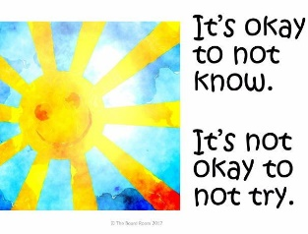
Tutor Signature: ___________________________

