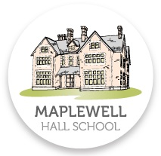

Student Exams Guide

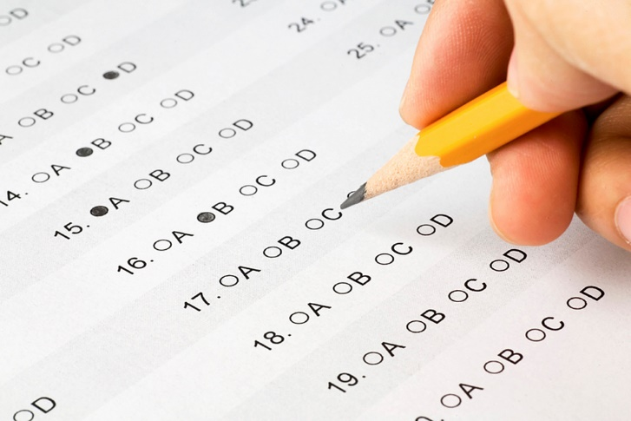

Challenge, Motivate & Inspire

Table of Contents

Preparation 3
Improve your reading skills 3
Make a revision timetable 3
Know what exams you are sitting 3
Check your timetable 3
Access Arrangements 4
Revision Tips 4
Flashcards 4
Choose and use your exam tools 4
Equipment you are allowed: 5
Equipment you are NOT allowed: 5
Preparation and revision is a choice – make the right one! 5
Exam Day 6
Start time 6
During the exam 6
Emergency evacuation 6
Results & Post Results Enquiries 7
Results 7
Post Results 7
Certificates 7
Malpractice 8
Contact Us 8

Preparation

Improve your reading skills
Improving your reading skills is the single most important thing you can do to prepare for your exams. Read every day; read to yourself; read to an adult; read fiction and non-fiction.

Make a revision timetable

Make a revision timetable and stick to it. Doing a little revision every day will help you to feel calm, cool and collected. Revising little and often will give you a much better chance of success.

Know what exams you are sitting

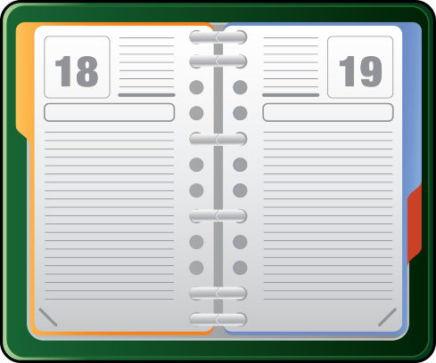
You will need to know the following information:
- The subjects you are entered for;
- The date of your exam;
- The time of your exam (please note that this is the actual start time, so you need to ensure you are at the exam room 15 minutes before the start time);
- Your candidate number – you will need this number to use for all of your exams.

Check your timetable

When you receive your timetable, check it carefully to make sure:
- All the subjects that you are meant to be taking appear on the list;
- That you are entered for the correct tier;
- That your personal details are correct. This is what will appear on your certificates. Please note that ONLY legal names will be printed on your certificate.
If you have changes or are unsure about anything on your exam timetable, please speak to your subject teacher or tutor.

Access Arrangements

All students that require access arrangements during their exams have already been identified. Evidence has been collated and applications have been made to the Awarding Body where appropriate. If you are entitled to any access arrangements for a particular subject, you will already have been informed by your class teachers.
If you have any queries in regards to these access arrangements, please speak to your teachers.

Revision Tips

Flashcards
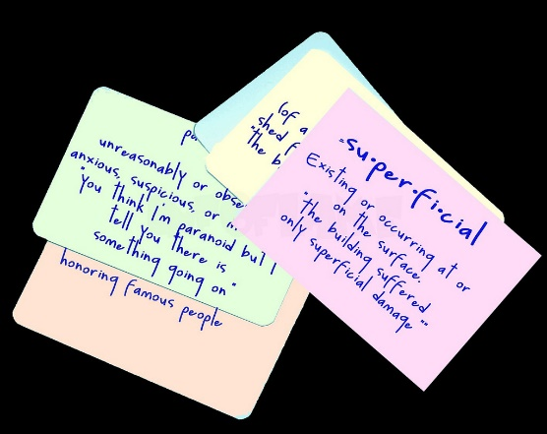
Research has shown that making your own flashcards, and using them regularly, is the most effective exam revision technique.
You can make flashcards out of card. Write a subject keyword or question on one side of the card, and definition or answer on the other side. You can then use the cards to test yourself, or get someone to use the cards to test you.

Make sure the information on your flashcards is accurate. Ask your subject teacher to check them. There is no point learning facts that are wrong!

Choose and use your exam tools

You are going to have to write with a black pen in the exam, practice using a black pen as often as possible. Try many different makes and styles of black pen. Once you have found a comfortable one, buy lots of them and stick to them. There is nothing worse than writing in an exam with a pen that does not suit you.
Do the same with any other exam equipment such as calculators; use your revision time to work out how they work so that you can concentrate on the exam questions rather than how you switch the calculator on.
If you are unable to obtain your own equipment, a set of stationary will be provided for you on your exam desk.

Equipment you are allowed:
- Black pen
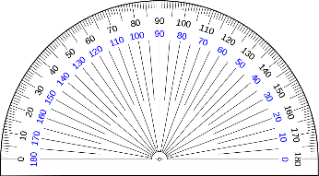
- Pencil
- Eraser
- Ruler
- Compass
- Protractor
- Calculator (if permitted)

Equipment you are NOT allowed:

You are NOT allowed to take into the exam room, any paper/notes, ipods, MP3 players, mobiles phones, smart watches, any other electronic devices, outside coats, hats, gloves etc. This must all be left outside of the exam room.
If you have mobile phones or any other electronic devices on you, these must be handed in at reception and not be brought into the exam room.
You are also NOT allowed to use correcting pens, fluid or tape, erasable pens, highlighters or gel pens in your answers.

Preparation and revision is a choice – make the right one!

If you choose not to revise and prepare, you are choosing to stress. This choice will lead to:
- Anxiety
- Tiredness
- Anger
- Difficulty concentrating
- Illness
- Poor performance
If you choose to revise and prepare, you are choosing confidence. This choice will lead to:
- Calm
- Happy
- Focused
- Best performance

Exam Day

Start time

All external exams start at the following times. Make sure you know when you exams are and arrive at the exam room 15 minutes before the start time.
Morning exams - 9:15am
Afternoon exams - 1.05pm
If you are late for an exam, you will need to see a member of the Senior Leadership Team (SLT). SLT and the Exams Officer will decide on what action needs to be taken. A student will be considered very late, if they arrive an hour after the official start time of the exam, i.e. 10:00am for morning exams and 2:30pm for afternoon exams. Where a student is very late, the Awarding Body will be notified. Please note it is at the discretion of the Awarding Body whether they choose to accept the work or not.

During the exam

You must ensure you:
- Always listen to and follow the instructions of the invigilator;
- Check that you have the right paper and answer booklet in front of you;
- Do not open the exam paper until you are instructed to do so by the invigilator;
- Read the instructions set out on the cover of your question paper;
- When your time is up, the invigilator will tell you to stop writing;
- All paper used must go inside the answer booklet. No paperwork should be taken from the exam room;
- Once all of the papers are collected, you will be dismissed from the exam room;
- Collect your belongings and please ensure you leave quietly. There may still be other students finishing the exam. You must not talk to anyone until you have left the room.

Emergency evacuation

If the fire alarm sounds, please listen carefully to the invigilator and do not panic. Please make sure that you follow these steps:
- Maintain complete SILENCE at all times, you will still be under exam conditions so you must not communicate with any other students in any way;
- Do not take anything out of the exam room. All papers, pens etc. must be left on your desk;
- Line up in the designated area remaining silent;
- When you return to the exam room, please await further instructions from the invigilator.

Results & Post Results Enquiries

Results
The school will post out results to students to be delivered on THURSDAY 22ND AUGUST 2019. Students will receive an individual results slip containing their grades. If you are missing a result or don’t understand your results or have concerns, please call the school to speak to a teacher or the Examinations Officer, Kelly Taylor on 01509 890 237.

Post Results

If you have any concerns, please contact the school. Do not contact the Awarding Body directly.
- Enquiries about results (EAR)
If you have any concerns about your results after they have been published, then speak to your subject teacher, Head of Department or the Exams Officer. They will be able to explain to you what (if anything) can be done regarding your query. All queries should be raised immediately as there are tight deadlines to be met if any action needs to be taken. The final decision on whether to process an EAR lies with the Senior Leadership Team.
- Access to scripts (ATS)
In some cases, teachers would like to use your script to help with teaching and learning. In all cases, your name and candidate number will be removed from the script before it is used. We require your permission in order to do this and if you would rather we didn’t, then please do not sign the form.

Certificates

Certificates are received by the school in November. Once received, any students that that have left Maplewell, will receive their certificates via recorded delivery. Students that stay on into K5, will receive their certificates personally at a later date.
Certificates will be kept on file for one year. After this point, they will be securely destroyed. Students who have lost their certificates or have not collected within the year will need to contact the Award Body for a replacement. Please note that there is a cost involved with this.

Malpractice

Any students that do not adhere to the rules and regulations set by the Awarding Bodies, the JCQ and Maplewell Hall School will be dealt with accordingly. This includes all exams, controlled assessments and non-exam assessments. A full investigation will take place and the Awarding Body will be notified. Penalties can range from a warning, to loss of marks for a unit, disqualification from qualification and in an extreme case, the student can be barred from taking any exams.

Contact Us

Maplewell Hall School
Woodhouse Eaves
Leicestershire
LE12 8QY
Phone: 01509 890 237
Email: admin@maplewell.leics.sch.uk
Web: www.maplewell.leics.sch.uk

