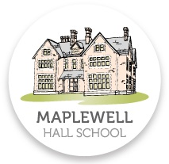

Parent Guide to Exams

Table of Contents

Introduction 3
How you can help 3
Make sure your child is at school every day and on time 3
It’s never too early to start revising! 3
Encourage them to complete their controlled assessment on time 4
Mock Exams 4
Tips to help your child revise effectively 4
Exam Day 5
What else can you do to help? 5
Contact Us 6

Introduction

The next few months are crucial for your child as they prepare to sit their GCSE exams. These are important exams for your child, as the grades achieved will determine what opportunities they will have in life. You will want your child to achieve the best grades that they can, and this can be made possible when there is a partnership between the student, the school and the parents.
Most information on how to succeed in exams, are aimed at helping the students. This booklet however is different; it is aimed at you, the parent. It looks at your perspectives on the exam process and advises you on how best to help and support your child during the run-up to GCSEs.
There are a number of simple things you can do as parents to help your child to be as prepared as possible. During the run-up to exams, stress levels can rise and there may be times when you feel that you are sitting the exams rather than your child. However, with your help and support, you will prove valuable!

How you can help

You don’t have to be an expert in any of the subjects your child studies to make a difference, you just need to know how best to spend the time you have in order to support them. Your support, encouragements and interest can make a big different to your child’s motivation and ability to cope with the academic and organisational demands during the exam period.

Make sure your child is at school every day and on time

Make sure your child attends school on time and understands the importance of making the most of lesson times. Government statistics show that there is a link between attendance, punctuality and results at GCSE. Every day lost in attendance reduces your child’s chance of achieving their best.

It’s never too early to start revising!
It is best for students to start revision early and to keep revising during the year by doing little but often. This will give your child time to review what he/she has studied and to strengthen their memory. This will avoid the panic of leaving things to the last minute.
Most GCSE exams will begin from mid-day and run until the end of June but some take place earlier i.e. language orals and practical examinations. Your child will be given a timetable. Have a copy of the timetable at home not just to check dates but so that you can make sure they are equipped for each exam and to provide encouragement.

Encourage them to complete their controlled assessment on time

Controlled assessments count and can make a huge difference to a student’s final grade. In some subjects, coursework counts for as much as 60% of the marks. If controlled assessments/non exam assessments are handed in on time, your child may get feedback from their teacher on how it could be improved (if at all possible) in order to improve their grade. Urge them not to leave everything until the last minute. They will panic, probably rush it and not do as well because they are under pressure.

Mock Exams

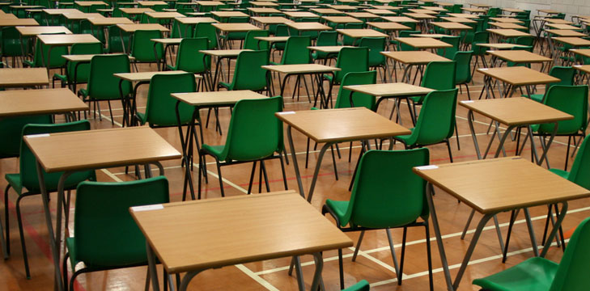
Mocks are held in Year 11, giving your child a chance to learn how to work under timed conditions in an exam environment. Current grades are based on mock exams results and there’s knowledge of your child’s work. If your child’s grades are disappointing, encourage them to talk to their teachers and start working on the subjects where they need to improve. Mocks are a trial run. Students need to learn from them and adapt their strategies if needed.

Tips to help your child revise effectively

- Agree the rules for homework or revision, helping them to make a realistic timetable, balancing work time against recreation time and reviewing the plans as necessary. Have the timetable displayed in their room to help them stick to the plan.
- Ensure they have the time and somewhere to study. Encourage the rest of the family to give them space and peace whilst they revise.
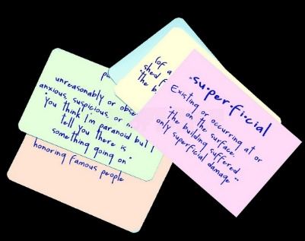
- Encourage your child to use the revision methods they have been taught i.e. mind maps, flashcards, brief notes, pictures, spider diagrams. Just reading things through doesn’t always work! The more they process information, the more likely it is to stick!
- Encourage them to attend revision sessions offered by the school and ask for help on subjects they don’t understand.
- Make sure they eat properly and drink plenty of water. The brain works better when the body is fed and watered!
- Emphasise the need for plenty of sleep, especially the night before an exam.
- No matter what they tell you, television and loud music do not help revision, but quiet background music might!
- Go along to Parent’s Evening, ask questions to find out how you can help your child at home;
- Ask to see their revision notes and check how they are doing by letting them explain something to you. If you understand the explanation, then they will be able to produce a good answer in the exam. Try to be positive and reassuring to build their confidence;
- Make sure they continue to attend lessons up to the examination in each subject.
- Ask them to put their social life on hold; they can celebrate when it’s all over. Allow them to revise with a friend as this can help.

Exam Day

Ensure they get up on time and are at school on time.
- Equipment;
- Not wearing a watch – must be removed in the exam;
- Ensure they are dressed appropriately and in school uniform;
- Insist they turn their mobiles phones off before handing them in to reception;
- Wish them luck as they leave.
You should encourage your child to eat before an exam, avoid skipping breakfast or not eating because they are too nervous. Very simply, their brains need the energy from food to work efficiently. It would be a shame to have studied intensively before an exam and then be too fatigued physically to do their best on the exam day.
Encourage your child to drink water throughout the day. Dehydration can make you lose concentration, feel faint and drain your energy. By the time they feel thirsty, they are already dehydrated.

What else can you do to help?

- Recognise the importance of GCSE exams and the preparation time needed to do well;
- Reward your child’s efforts to revise;
- Reduce the number of chores that they have to do when exams start;
- Make sure that the whole family respects the importance of keeping disturbances to a minimum;
- Be sensitive to the pressure and stress that your child may be experiencing. Encourage them to speak to you about it;
- Make sure that time is built in for exercise and recreation;
- Respect their growing independence. Ask them how you can best support them;
- Help them to keep things in perspective.

Contact Us

There are a team of people who are here to help your child through their time at Maplewell:
Head Teacher Mr Brooks
Deputy Head Teacher Mr Hoult
Deputy Head Teacher Mr Cooper
Assistant Head Teacher Mrs Ison
Assistant Head Teacher Mr Leaney
Assistant Head Teacher Mrs Glinka
Examinations Officer Miss Taylor

If you have any questions or concerns, please get in touch on 01509 890 237.

Remember, how you approach the next few months can have a real impact on your child’s future. Studies show that high parental interest is linked with better exam results. What will you do to give your child the best chance of achieving success?

